Table of Contents
What is lifestyle medicine and how does it fit into undergraduate medical education (UME)? 2
What is UME Curriculum Certification? 2
Why certify my medical school’s curriculum? 3
Frequently Asked Questions 4
How do I become eligible to apply? 4
How do I get my medical school’s curriculum certified by the ACLM Curriculum Certification Committee? 5
How do my students receive documentation of completion of our certified curriculum? *platinum institutions or plus designation 6
Appendix A 7
PDF ACCESS: Undergraduate Medical Education: Lifestyle Medicine Curriculum Implementation Standards (sagepub.com) 7
UME Lifestyle Medicine Competencies 7
References 9

What is lifestyle medicine and how does it fit into undergraduate medical education (UME)?
Lifestyle medicine is a medical specialty that uses therapeutic lifestyle interventions as a primary modality to treat chronic conditions including, but not limited to, cardiovascular diseases, type 2 diabetes, and obesity. Lifestyle medicine certified clinicians are trained to apply evidence-based, whole-person, prescriptive lifestyle change to treat and, when used intensively, often reverse such conditions. Applying the six pillars of lifestyle medicine—a whole-food, plant-predominant eating pattern, physical activity, restorative sleep, stress management, avoidance of risky substances and positive social connections—also provides effective prevention for these conditions.¹
In 2017, the American Medical Association passed a resolution to support the inclusion of lifestyle medicine education in undergraduate, graduate, and continuing medical education.² While a majority of Americans live with one or more chronic health conditions with roots in lifestyle behaviors, and these same conditions account for up to 90% of health care spending, physicians continue to report lack of confidence in their knowledge and skills to address lifestyle during clinical visits, despite believing it their responsibility to do so.³

The 2017-2018 AAMC Curriculum Inventory Report on Lifestyle Medicine shows that of 123 participating medical schools, 111 (90%) documented lifestyle medicine education content delivered in various forms. While medical schools are increasingly incorporating lifestyle medicine into their curriculum, most implemented curricula fall short of expert recommendations.⁴

What is UME Curriculum Certification?

American College of Lifestyle Medicine (ACLM) Curriculum Certification Committee has utilized an expert consensus process for developing competencies for medical school lifestyle medicine curriculum implementation. These competencies fall within the framework of the Accreditation Council for Graduate Medical Education (ACGME) Core Competencies, guided by the Association of American Medical Colleges’ (AAMC) Core Entrustable Professional Activities (EPAs) and the American Board of Lifestyle Medicine’s (ABLM) lifestyle medicine certification competencies. In 2021, these competencies (within patient care and procedural skills; medical knowledge; practice based-learning and improvement; interpersonal and communication skills; professionalism; and systems-based practice) were published alongside standards for how medical schools may receive certification for integrating lifestyle medicine into their curriculum, detailing how students can pursue board certification in lifestyle medicine through an Educational Pathway.⁵
See appendix A for competencies and to download the full AJLM Curriculum Implementation Standards publication

By using a tiered approach to evaluate lifestyle medicine curriculum integration, the ACLM Curriculum Certification Committee certifies institutions based on the number of hours students spend in lifestyle medicine training, the percentage of competencies met, and the enrichment opportunities that are available.

Please see Table 1 for details on how academic institutions can fall within one of four tiers and receive a plus designation. Every tier must also have a Lifestyle Medicine Interest Group that is affiliated with ACLM. All competencies and processes are evaluated by the ACLM Curriculum Certification Committee. Once certified, institutions submit interim reports every 5 years to maintain their tier designation. Opportunities for tier advancement are possible based on institutional curricular refresh.
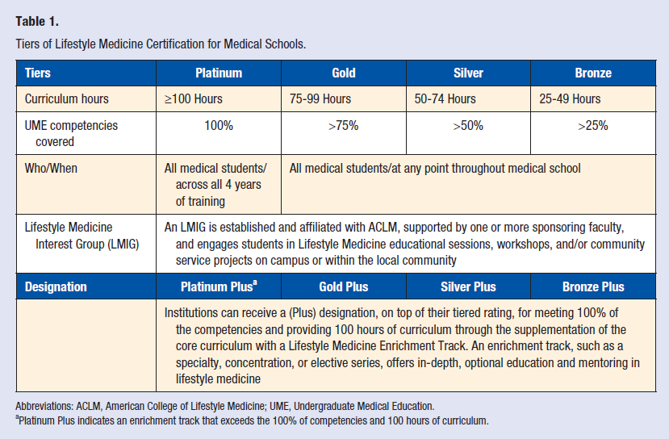

Why certify my medical school’s curriculum?
Medical students consider addressing lifestyle factors such as nutrition and physical activity important to their future careers, but upon graduation overwhelmingly do not feel equipped to meaningfully engage patients on these topics.^{6,7} Today’s students are interested in learning lifestyle medicine, and desire sufficient training to be healthy lifestyle role models for patients and provide effective health behavior change counseling.⁸
ACLM wants to provide a pathway to help medical schools address these discrepancies. Through providing educational resources to medical schools and recognition of medical schools’ achievements in training their doctors in chronic disease prevention, treatment, and reversal, the UME Certification process aids in institutional achievement in lifestyle medicine training, converging into national systemic change through encouragement, support, and publicization of those achievements.

Frequently Asked Questions

How do I become eligible to apply?
- Establish a Lifestyle Medicine Interest Group
  - Visit www.lifestylemedicine.org/lmig to access the toolkit and application
- Ensure your institution’s curriculum includes at least 25 hours and covers 25% of the UME competencies

The Educational Pathway requires 100 hours of lifestyle medicine education that covers 100% of the UME competencies. A flexible and adaptive model with approximately 40 hours of didactic and 60 hours of application activities is proposed to support the Liaison for Committee on Medical Education’s (LCME) expectation that individual and unique medical school curricula exist across institutions. This enables each institution to adapt, as necessary, to their unique circumstances and teaching methods.
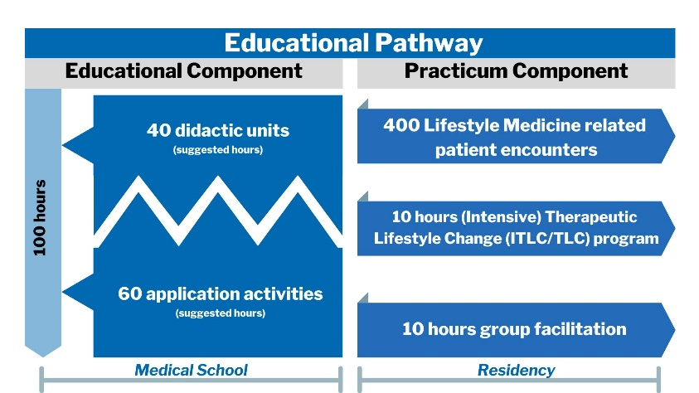
The ACLM Curriculum Certification Committee recommends the 100 hours be divided across ten topic areas to be in alignment with the distribution of the ABLM lifestyle medicine certification competencies in Table 2, with the educational hour requirements for nutrition meeting the minimum nutrition education recommendation put forth by the National Academy of Sciences.^{9,10}

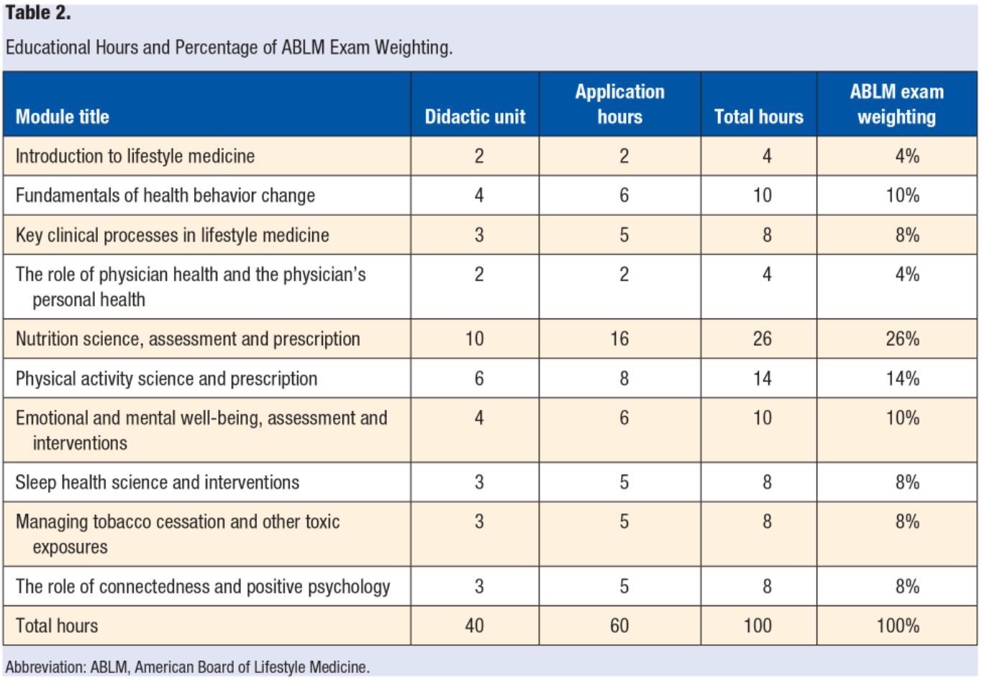
In order to qualify for Bronze recognition or higher, more than 25 hours of curriculum covering 25% of the competencies is required.

ACLM encourages implementing LM concepts and topics into the curriculum throughout all four years of medical school to present the content at an optimal time for shaping a student’s understanding and approach to comprehensive patient care. Medical schools may augment preexisting curriculum by incorporating UME competencies into lectures, pathophysiology review, case studies, and clinical application activities in order to meet the recommended standards of LM implementation. The ACLM UME Curriculum Certification Committee encourages the first two years of medical school lifestyle medicine education to focus on the didactic education of lifestyle medicine, while the third and fourth clinical years present opportunities for in-depth, hands-on learning and clinical application of lifestyle medicine.

How do I get my medical school’s curriculum certified by the ACLM Curriculum Certification Committee?

- Create a New Account
- Click “Register”
- Complete the initial phase of the application
  - Provide your primary contact applicant information
  - List any prospective personnel (faculty, administrators, LMIG M2-M4 students) who may be assisting in curriculum mapping.
    - For continuity, determine an individual (faculty or administrator) at your academic institution who will attest to the students' completion of the 100 hours of didactics (educational component).
  - Indicate all types of lifestyle medicine integration at your academic institution.
  - Indicate your interest in receiving a scholarship and indicate the certification tier you believe you are eligible for.
  - Click “Save and Finalize”
- Meet with ACLM staff to confirm your eligibility to apply for curriculum certification
  - See following FAQ section and publications for more details on eligibility
- Purchase the application package ($1000)
  - Log in to your existing account
  - Under “My Applications” view “Needs Attention” and click “Open”
  - Add the Application Package to your cart
    - If you received a scholarship, your cart will indicate “$0.00”
  - Click “Checkout” and “Finalize”
- Complete the final phase of the application
  - Under “My Applications” view “Needs Attention” and click “Open”
  - Review the Application Toolkit
  - Download, fill out, and upload the Module Delivery Template Excel spreadsheet.
  - Click “Save and Finalize”
- Meet with ACLM Curriculum Certification Committee to receive feedback and additional supportive resources
- Receive official tier designation from the ACLM Curriculum Certification Committee

How do my students receive documentation of completion of our certified curriculum? *platinum institutions or plus designation

- Provide ACLM with graduate information
  - Medical school provide roster of students to ACLM
  - ACLM provides qualified students with the opportunity to complete the practicum component of the Educational Pathway through a residency program adopting the Lifestyle Medicine Residency Curriculum.
  - Upon completion of the Practicum Component of the Educational Pathway, residents receive a letter to submit to ABLM upon certification registration.
  - Students complete the Foundations of Lifestyle Medicine Board Review Course (30 hours) to ensure standardization and prepare for success on the ABLM certification exam.
    - Students receive a 50% discount
    - Must complete within 3 years of certification exam

Appendix A

PDF ACCESS: Undergraduate Medical Education: Lifestyle Medicine Curriculum Implementation Standards (sagepub.com)

UME Lifestyle Medicine Competencies
PC: Patient care and procedural skills
MK: medical knowledge
PBL: practice based-learning and improvement
IC: interpersonal and communication skills
P: professionalism
SBP: Systems-based practice
PC1: Conduct a comprehensive, lifestyle focused history and physical examination, including appropriate screenings, to assess the six pillars of Lifestyle Medicine. (EPA 1)
PC2: Apply evidence-based Lifestyle Medicine guidelines for the development of a comprehensive Lifestyle Medicine assessment and plan for chronic disease prevention, treatment and reversal, including Lifestyle Medicine prescriptions. (EPA 7)
PC3: Effectively apply clinical reasoning skills when ordering and interpreting appropriate tests to screen, diagnose, and guide the prevention, treatment and reversal of common lifestyle-related chronic diseases. (EPA 3, 7)
PC4: Utilize evidence-based models of health behavior change to assess patients' readiness and ability to make lifestyle changes. (EPA 7)
PC5: Utilize evidence-based behavior change counseling to support patients in lifestyle changes. (EPA 7)
PC6: Collaborate in a patient-centered approach with patients and their families to develop evidence-based, achievable, specific, written action plans such as lifestyle prescriptions. (EPA 9)
PC7: Apply pharmaceutical knowledge to adjust medication doses as patients adopt a healthier lifestyle. (EPA 4, 5)
PC8: Compare effective dosing of Lifestyle Medicine strategies based on progression and severity of disease. (EPA 4)
M1: Discuss the pathophysiology of lifestyle-related chronic diseases.
M2: Evaluate and discuss the scientific evidence and physiological mechanisms by which lifestyle changes can treat and reverse lifestyle-related chronic disease. (EPA 7)
M3: Discuss how lifestyle related chronic disease treatment and reversal is dependent on disease severity and Lifestyle Medicine intervention dose.
M4: Discuss the six pillars of Lifestyle Medicine and the expected disease prevention, treatment and reversal outcomes when Lifestyle Medicine is utilized.
M5: Demonstrate how the six pillars of Lifestyle Medicine fit into a comprehensive treatment framework including pharmaceuticals and surgery. (EPA 9, 10, 11)
PBL1: Critically evaluate national guidelines for alignment with the six pillars of Lifestyle Medicine. (EPA 7)
PBL2: Utilize resources to locate, interpret and apply evidence from scientific studies regarding Lifestyle Medicine to prevent, treat and reverse lifestyle-related chronic disease. (EPA 7)
PBL3: Work collaboratively within an interprofessional team dedicated to multifactorial lifestyle change. (EPA 9)
PBL4: Utilize information technology to optimize the delivery of lifestyle interventions and track changes over time. (EPA 5)
IC1: Collaborate with patients and their family members utilizing effective patient-centered relationship skills and shared decision-making to cultivate confidence and readiness for action. (EPA 1, 11)
IC2: Communicate and effectively lead an interprofessional healthcare team related to Lifestyle Medicine treatment plans and goals. (EPA 8, 9)
IC3: Educate patients, students, residents and other health professionals on the appropriate use of Lifestyle Medicine as a sustainable approach for prevention, treatment and reversal of lifestyle related chronic disease.
IC4: Tailor lifestyle education based on the health literacy and learning needs of the patient. (EPA 1, 2)
P1: Describe how a physician’s personal Lifestyle Medicine engagement can benefit patients’ health behaviors.
P2: Demonstrate compassion, respect, and autonomy for patients, regardless of their readiness or ability to engage in lifestyle change.
P3: Model an authentic journey of healthful lifestyle choices.
P4: Demonstrate the ability to perform Lifestyle Medicine counseling in a culturally competent manner.
SBP1: Describe the role of Lifestyle Medicine within the healthcare system framework. (EPA 9, 13)
SBP2: Advocate for policies that support treating the root cause of chronic disease through Lifestyle Medicine. (EPA 13)
SBP3: Describe practice systems that support and optimize Lifestyle Medicine-focused interventions. (EPA 13)
SBP4: Describe costs of common lifestyle related chronic diseases at the individual, health care system and community level and the impact of Lifestyle Medicine interventions on cost containment. (EPA 13)
SBP5: Integrate appropriate Lifestyle Medicine referrals to community organizations and health care professionals into patient treatment plans. (EPA 8, 9)
SBP6: Describe how Lifestyle Medicine can decrease health inequities among populations experiencing higher burdens of chronic disease, including adaptation strategies for patients and populations with limited resources. (EPA 13)

References
1. Lifestyle Medicine. https://www.lifestylemedicine.org/ACLM/About/What_is_Lifestyle_Medicine_/Lifestyle_Medicine.aspx. Accessed June 27, 2022.
2. H-425.972 Healthy Lifestyles. American Medical Association. https://policysearch.ama-assn.org/policyfinder/detail/lifestyle%20medicine?uri=%2FAMADoc%2FHOD.xml-0-3746.xml. Accessed June 27, 2021.
3. Phillips E, Pojednic R, Polak R, Bush J, Trilk J. Including lifestyle medicine in undergraduate medical curricula. Medical education online. 2015;20(1):26150.
4. Trilk JL, Muscato D. Progress of Lifestyle Medicine Education. AAMC Curriculum Inventory in Context. 2019;6(1):1-8.
5. Trilk JL, Worthman S, Shetty P, et al. Undergraduate Medical Education: Lifestyle Medicine Curriculum Implementation Standards. Am J Lifestyle Med. 2021.
6. Frantz DJ, McClave SA, Hurt RT, Miller K, Martindale RG. Cross‐sectional study of US interns' perceptions of clinical nutrition education. Journal of Parenteral and Enteral Nutrition. 2016;40(4):529-535.
7. Dunlop M, Murray AD. Major limitations in knowledge of physical activity guidelines among UK medical students revealed: implications for the undergraduate medical curriculum. British journal of sports medicine. 2013;47(11):718-720.
8. Lee JS, Xierali IM, Jaini PA, Jetpuri Z, Papa F. Medical Student Perception of Lifestyle Medicine and Willingness to Engage in Lifestyle Counseling: A Pilot Study of Allopathic and Osteopathic Medical Students. Am J Lifestyle Med. 2021:15598276211004449.
9. Adams KM, Kohlmeier M, Zeisel SH. Nutrition education in US medical schools: latest update of a national survey. Academic medicine: journal of the Association of American Medical Colleges. 2010;85(9):1537.
10. Rea B, Worthman S, Shetty P, Alexander M, Trilk JL. Medical Education Transformation: Lifestyle Medicine in Undergraduate and Graduate Medical Education, Fellowship, and Continuing Medical Education. Am J Lifestyle Med. 2021:15598276211006629.

